# TITLE PAGE

**AUTOMATED INFORMATION SYSTEM OF STUDENT WITH NATIONAL DIPLOMA (CASE STUDY OF 2010 – 2020 COMPUTER SCIENCE, FEDERAL POLYTECHNIC, MUBI)**

**BY**

**BITRUS USA**

**ST/CS/ND/21/011**

**DEPARTMENT OF COMPUTER SCIENCE,**

**SCHOOL OF SCIENCE AND TECHNOLOGY,**

**FEDERAL POLYTECHNIC, MUBI, ADAMAWA STATE.**

**IN PARTIAL FULFILLMENT OF THE REQUIREMENT FOR THE AWARD OF NATIONAL DIPLOMA (ND) IN COMPUTER SCIENCE.**

**SEPTEMBER, 2023**

# DECLARATION

I hereby declare that the work in this project titled **“Automated Information System of Student with National Diploma (Case Study of 2010 – 2020 Computer Science, Federal Polytechnic, Mubi)”** was performed by me under the supervision of Mal. Mustapha Garba Sintali. The information derived from literatures has been duly acknowledged in the text and a list of references provided. The work embodied in this project is original and had not been submitted in part or in full for any other diploma or certificate of this or any other institution.

BITRUS USA ________________ _______________

(ST/CS/ND/21/011) Signature Date

# CERTIFICATION

This project titled **“Automated Information System of Student with National Diploma (Case Study of 2010 – 2020 Computer Science, Federal Polytechnic, Mubi)”** meets the regulations governing the award of National Diploma (ND) in Computer Science, Federal Polytechnic Mubi, Adamawa State

Mal. Mustapha Garba Sintali __________________

(Project Supervisor) Sign/Date

Mr. Mustapha Kassim __________________

(Head of Department) Sign/Date

Mal. Abdulrahman Saidu _________________

(External Examiner) Sign/Date

# DEDICATION

This project is dedicated to my beloved parents for their advice, encouragement and financial support towards my academic pursuit.

# ACKNOWLEDGEMENTS

I want to acknowledge Almighty God for his infinite mercy and protection throughout my academic activities. And for the understanding in achieving our academic success.

I also recognize my Supervisor Mal. Mustapha Garba Sintali, who took time, despite her busy schedule to directed and guided me throughout this research work.

I also acknowledge the Head of Department Computer Science Mr. Mustapha Kassim for his moral encouragement throughout my period of study. I also acknowledge all Staff of Computer Science Department for their support and encouragement and the knowledge they’ve impacted on me throughout our studies.

I also want to appreciate our parents for their love and care and for giving me the opportunity to be trained and achieve our dreams.

Finally, I appreciate the efforts of my Uncles and aunties, for their encouragement and support throughout the course of our study and also our friends and relatives, course mates and all well-wishers. I love you all, may the Almighty God bless you abundantly, Amen.

# TABLE OF CONTENTS

TITLE PAGE i

DECLARATION ii

CERTIFICATION iii

DEDICATION iv

ACKNOWLEDGEMENTS v

TABLE OF CONTENTS vi

LIST OF FIGURES viii

LIST OF TABLES ix

ABSTRACT x

CHAPTER ONE 1

INTRODUCTION 1

1.1 Background to the Study 1

1.2 Problem Statement 2

1.3 Aim and Objectives 3

1.4 Significance of the Study 3

1.5 Scope of the Study 3

1.6 Definition of Some Operation Terms 4

CHAPTER TWO 5

LITERATURE REVIEW 5

2.1 Introduction 5

2.2 Automated Information Systems in Education 5

2.2.1 Characteristics of Automated Information Systems 5

2.1.2 Importance of AIS in Enhancing Education 6

2.2 Automated Information Systems in Higher Education Institutions 6

2.2.1 Academic Record Management 7

2.2.2 Student Services Enhancement 7

2.2.3 Administrative Task Streamlining 7

2.2.4 Organizational Insight and Decision-Making 8

2.3 Student Information Management Systems (SIMS) 8

2.4 Information Management System 9

2.4.1 Importance of Information Management Systems 9

2.5 Database Management System 10

2.6 Related Studies 11

CHAPTER THREE 12

SYSTEM ANALYSIS AND DESIGN 12

3.1 Introduction 12

3.2 Disadvantages of the Existing System 12

3.3 Advantages of the Proposed System 12

3.4 The Proposed Method 13

3.5 Method of Data Collection 14

3.6 System Design 14

3.6.1 Algorithm Diagram 15

3.7 System Requirements Specification 19

3.7.3 Personnel Requirements 19

CHAPTER FOUR 20

RESULTS AND DISCUSSION 20

4.1 Introduction 20

4.2 Results 20

4.3 Discussion 23

4.4 User manual 24

CHAPTER FIVE 25

SUMMARY, CONCLUSION AND RECOMMENDATIONS 25

5.1 Summary 25

5.2 Conclusion 25

5.3 Recommendations 25

5.4 Contribution to Knowledge 26

5.5 Area for Further Work 26

REFERENCES 27

APPENDICES 30

# LIST OF FIGURES

Figure 3.1: Waterfall Model - - - - - - - - 14

Figure 3.2: Use Case Diagram - - - - - - - 15

Figure 3.3: System Architecture - - - - - - 16

Figure 3.4: Database Entity Relationship Diagram - - - - - 18

Figure 3.5: Login interface - - - - - - - - 18

Figure 3.6: Registration Interface - - - - - - - 19

Figure 3.7: Apply for Promotion Interface - - - - - - 19

Figure 3.8: Add Department - - - - - - - - 20

Figure 3.9: Add Level - - - - - - - - - 20

Figure 4.2.1: Welcome Interface - - - - - - - 22

Figure 4.2.2: Login page interface - - - - - - - 22

Figure 4.2.3: Registration Interface - - - - - - - 23

Figure 4.2.4: Apply for Promotion Interface - - - - - - 23

Figure 4.2.5: Promotion Request Interface - - - - - - 24

Figure 4.2.6: Create New Department - - - - - - 24

Figure 4.2.7: Create Level Interface - - - - - - - 25

Figure 4.2.8: Dashboard Interface - - - - - - - 25

# LIST OF TABLES

Table 3.1: **Users Table** - - - - - - - - - 16

Table 3.2: **Departments Table** - - - - - - - - 17

Table 3.3: **Designation Table** - - - - - - - - 17

Table 3.4: **Promotion Table** - - - - - - - - 17

# ****ABSTRACT****

*Despite the great efforts to assure quality in higher education institutions, the ambiguity 01' its related concepts and requirements constitute a big challenge when trying to implement it as an automated information system. The present work introduces a framework for an automated information system that manages the quality assurance in higher educations institutions. The aim 01' designing such a system is to provide an automation tool that avoids unnecessary and redundant tasks associated to quality in higher education institutions. In addition, the proposed system hel ps all higher education stockholders to handle and monitor their tasks. Moreover, it aims to help the quality assurance center in a higher education institution to apply its qualitys standards, and to make sure that they are being maintained and enhanced.*

# CHAPTER ONE

# INTRODUCTION

## 1.1 Background to the Study

In the era of digital transformation, the integration of automated information systems has revolutionized various sectors, including education. Educational institutions are embracing technology-driven solutions to enhance operational efficiency, streamline administrative processes, and improve the overall educational experience for students. As the volume of data generated within academic settings continues to grow, the need for effective information management becomes increasingly pronounced. In today's rapidly evolving technological landscape, information systems play a pivotal role in transforming various sectors of society. One such sector is education, which has witnessed significant advancements in the way information is managed, processed, and disseminated. Educational institutions around the world have been increasingly adopting automated information systems to streamline administrative processes, enhance communication, and improve overall efficiency (Wu & Brown, 2022).

The Federal Polytechnic, Mubi, located in Nigeria, is no exception to this trend. The institution has been grappling with the challenges associated with manual information management systems. These challenges include data entry errors, time-consuming administrative tasks, difficulties in accessing accurate and timely information, and limitations in data analysis and reporting. The National Diploma (ND) program in Computer Science, spanning the years 2010 to 2020, has accumulated a substantial amount of student-related data, including registrations, academic records, and other administrative data. The use of traditional paper-based methods and standalone computer applications for managing this data has hindered efficient information retrieval and utilization (Huang, 2021).

Recent studies emphasize the pivotal role of automated information systems in education. According to Dizon and Badilla (2020), the adoption of such systems significantly improves administrative processes, communication, and decision-making in educational institutions. In a study by Alzahrani *et al.* (2021), it was observed that automated information systems contribute to enhanced student satisfaction and improved service delivery. Moreover, the impact of automated information systems on academic institutions has been recognized globally. A case study conducted by Kim and Kim (2020) on the implementation of an integrated student information system in a South Korean university highlighted how the system led to improved student services and resource optimization. Similarly, a study by Hoang and Nguyen (2020) explored the implementation of an automated student management system in Vietnamese universities, showcasing the positive effects on administrative efficiency and data accuracy.

The significance of automated information systems in streamlining educational processes is evident in various contexts. For instance, Al-Badawi and Al-Zaidi (2018) examined the implementation of an automated student registration system in a Saudi Arabian university and noted its role in reducing administrative burdens and minimizing errors. Similarly, the study by Kulkarni *et al.* (2019) focused on the implementation of an automated examination management system in an Indian university, leading to improved examination scheduling and result processing. Given the challenges faced by the Federal Polytechnic, Mubi, and the potential benefits highlighted by recent research, there is a compelling need to design and develop an Automated Information System tailored specifically for students with National Diploma in Computer Science. This system will address the limitations of manual processes and pave the way for more efficient data management, streamlined administrative tasks, and improved service delivery.

## 1.2 Problem Statement

The problem statement for the research project titled "Automated Information System for Students with National Diploma: A Case Study of 2010-2020 Computer Science, Federal Polytechnic, Mubi" is as follows:

1. The Federal Polytechnic, Mubi, has been facing challenges in effectively managing student information and administrative processes within its National Diploma (ND) program in Computer Science, spanning the years 2010 to 2020.
2. The current manual methods of record-keeping and information management are prone to errors, time-consuming, and hinder the timely delivery of services to students and other stakeholders.
3. The accumulation of student-related data, including registrations, academic records, and administrative data, has created a need for an efficient and accurate system that can streamline data management, enhance communication, and improve overall operational efficiency.
4. The absence of an automated information system tailored specifically for ND students in Computer Science has led to inefficiencies in data retrieval, reporting, and decision-making, thereby negatively impacting the quality of student services and administrative processes.

There is a pressing need for an automated information system that can address these challenges and provide a streamlined solution for managing student-related data and processes.

## 1.3 Aim and Objectives

The aim of this project is to design and implement an Automated Information System (AIS) for students with National Diploma in Computer Science at the Federal Polytechnic, Mubi, covering the period from 2010 to 2020. The specific objectives are as follows:

1. To analyze the existing manual information management processes for ND students in Computer Science at the Federal Polytechnic, Mubi.
2. To identify the key requirements and functionalities of an Automated Information System for student data management.
3. To design a user-friendly and efficient Automated Information System that encompasses student registration, academic records, and administrative processes.
4. To develop the proposed Automated Information System using appropriate software development tools and methodologies.
5. To evaluate the usability, effectiveness, and efficiency of the developed system through user testing and feedback.

## 1.4 Significance of the Study

The successful implementation of an Automated Information System for students with National Diploma in Computer Science at the Federal Polytechnic, Mubi, holds several potential benefits: The automated system is expected to significantly reduce the time and effort required for various administrative tasks, leading to improved efficiency and productivity. Students will benefit from streamlined registration processes, easy access to academic records, and timely communication, thereby enhancing their overall learning experience. Automation will minimize the risk of errors associated with manual data entry and manipulation, ensuring accurate and up-to-date information. The system may lead to better resource allocation, as staff can redirect their efforts from manual data management to more value-added tasks. Administrators will have access to real-time data and analytics, facilitating informed decision-making and strategic planning.

## 1.5 Scope of the Study

This study focuses specifically on developing an Automated Information System for students with National Diploma in Computer Science at the Federal Polytechnic, Mubi, covering the period from 2010 to 2020. The system will address student registration, academic record management, and selected administrative processes. The research project is limited to the constraints of time, resources, and the available technology stack.

## 1.6 Definition of Some Operation Terms

**Automation:** Automation in the context of a Departmental Fees Payment System involves the use of software and technology to perform fee-related tasks and processes that would otherwise be done manually (Wu & Brown, 2022).

**Database**: A database refers to an organized collection of structured data that is stored, managed, and accessed using specific software and methodologies (Lee & Koo, 2021).

**National Diploma (ND):** A National Diploma is a higher education qualification awarded to students upon successful completion of a specific course of study (Sutanto *et al*., 2020).

**Online**: Online refers to the state or mode of being connected to the internet or the use of computer networks to access and interact with information, services, or resources (Chen & Chen, 2021).

**Portal**: A portal refers to a web-based platform or gateway that provides access to various resources, information, and services (Li *et al*., 2020).

**Security Measures:** Security measures refer to a set of protocols, practices, and technologies implemented within the Departmental Fees Payment System to protect sensitive financial data, prevent unauthorized access, and safeguard against potential cyber threats or breaches (Anderson & Patel, 2022).

**System**: A system refers to a collection of interconnected components, processes, or elements that work together to achieve a specific purpose or objective (Huang, 2021).

# CHAPTER TWO

# LITERATURE REVIEW

## 2.1 Introduction

This chapter presents a comprehensive review of relevant literature pertaining to revenue generation, database management, and best practices in local government revenue collection. The literature review aims to establish a theoretical framework and contextual understanding that underpins the design and implement an Automated Information System (AIS) for students with National Diploma in Computer Science at the Federal Polytechnic, Mubi, covering the period from 2010 to 2020.

## 2.2 Automated Information Systems in Education

The digital age has ushered in a transformative era in education, marked by the integration of Automated Information Systems (AIS) into various aspects of academic institutions. These systems, driven by technology and data management, have redefined how educational institutions operate, communicate, and manage information. In this section, we delve into the concept of AIS in the context of education, exploring its fundamental characteristics and the pivotal role it plays in shaping modern educational landscapes. An Automated Information System (AIS) in the educational context refers to a software-driven solution designed to automate, streamline, and optimize various administrative and academic processes within an institution. It encompasses a range of functionalities, including data entry, storage, retrieval, analysis, and communication. AIS leverages technology to replace or enhance manual, paper-based methods, resulting in improved efficiency, accuracy, and accessibility of information.

## 2.2.1 Characteristics of Automated Information Systems

Data Integration: AIS integrates data from multiple sources and departments into a unified platform, allowing for seamless information sharing and collaboration among stakeholders.

Automation: AIS automates routine tasks such as student registration, record-keeping, attendance tracking, and grading. This automation reduces human errors and frees up administrative resources for more strategic activities.

Centralization: AIS centralizes data storage and management, eliminating the need for disparate systems and redundant data entry. This consolidation enhances data integrity and reduces redundancy.

Accessibility: AIS provides authorized users with secure, on-demand access to relevant data, enabling real-time information retrieval and decision-making.

Reporting and Analytics: AIS offers robust reporting and analytics capabilities, enabling administrators to generate insights from data and make informed decisions.

## 2.1.2 Importance of AIS in Enhancing Education

The adoption of AIS within educational institutions has far-reaching implications for various stakeholders, including students, faculty, administrators, and parents. AIS facilitates enhanced educational experiences and administrative processes in several ways:

Efficiency: AIS streamlines administrative tasks, reducing the time and effort required for processes like student enrollment, course registration, and grade submission.

Data Accuracy: Automated data entry minimizes errors and discrepancies, leading to accurate and reliable information for decision-making.

Communication: AIS enables seamless communication between students, faculty, and administrators through features such as notifications, announcements, and messaging platforms.

Resource Optimization: By automating routine tasks, AIS allows institutions to allocate resources more efficiently, focusing on strategic initiatives and student support.

Student Services: AIS enhances student services by providing easy access to academic records, schedules, and other relevant information, contributing to a positive learning experience.

Recent studies underscore the transformative impact of AIS in education. A study by Chen and Lin (2020) highlighted how the implementation of AIS in a Taiwanese university led to improved administrative efficiency and student satisfaction. Similarly, Ahadi et al. (2019) demonstrated how an AIS enhanced communication and collaboration among stakeholders in a Malaysian higher education institution.

## 2.2 Automated Information Systems in Higher Education Institutions

Automated Information Systems (AIS) have become an integral component of higher education institutions, fundamentally reshaping the way these institutions operate, interact with stakeholders, and manage data. This section delves deeper into the significant role AIS plays within higher education, exploring its multifaceted impact on academic record management, student services, and administrative tasks.

## 2.2.1 Academic Record Management

One of the primary functions of AIS in higher education is the management of academic records. Traditional paper-based record-keeping systems often result in challenges such as data loss, inefficiency, and limited accessibility. AIS addresses these issues by providing a comprehensive digital repository for academic records, including course enrollments, grades, transcripts, and degree progress.

AIS facilitates efficient record updates, ensuring that academic achievements are accurately recorded and readily available. This has a direct impact on academic advising and program planning, allowing students and advisors to make informed decisions about course selection and degree pathways. A study by García-Peñalvo *et al.* (2019), showcased the benefits of AIS in academic record management, emphasizing improved data accuracy and streamlined administrative processes.

## 2.2.2 Student Services Enhancement

AIS contributes significantly to enhancing student services, fostering a more student-centered approach to education. Through online portals and self-service features, students gain access to essential information such as class schedules, registration, financial aid, and academic progress. This accessibility empowers students to take control of their educational journey, reducing reliance on administrative staff and enhancing overall satisfaction. Furthermore, AIS enables personalized communication between students and faculty, facilitating timely feedback and support. This is particularly evident in the work of Trushkowska *et al.* (2020), which demonstrated that AIS implementation led to improved student-faculty interaction and increased student engagement.

## 2.2.3 Administrative Task Streamlining

AIS revolutionizes administrative processes within higher education institutions. Tasks such as admissions, enrollment, and billing are automated, reducing paperwork, minimizing errors, and expediting response times. Administrative staff can focus on strategic initiatives rather than being burdened by manual data entry and repetitive tasks.

AIS also supports faculty in various ways, such as facilitating electronic grading and attendance tracking. This was evident in a study by Rezk *et al.* (2021), where AIS implementation improved faculty efficiency and reduced administrative workload.

## 2.2.4 Organizational Insight and Decision-Making

The data collected and managed by AIS provide higher education institutions with valuable insights into student performance, enrollment trends, and resource utilization. This data-driven approach enhances decision-making processes, enabling administrators to identify areas for improvement, allocate resources strategically, and develop evidence-based policies.

Recent studies by Abdullah *et al.* (2022), emphasized the role of AIS-generated analytics in supporting informed decision-making, contributing to the institution's overall effectiveness. In summary, the role of AIS in higher education institutions is far-reaching and transformative. Through effective academic record management, student services enhancement, administrative task streamlining, and data-driven decision-making, AIS optimizes operations, enhances student experiences, and positions institutions for continuous improvement.

## 2.3 Student Information Management Systems (SIMS)

Student Information Management Systems (SIMS) play a pivotal role in modern educational institutions by providing a comprehensive and integrated platform for managing student-related data, academic records, and administrative processes. This section delves into the significance of SIMS, its key functionalities, and recent advancements in its implementation, supported by recent citations. A Student Information Management System (SIMS) is a software application designed to centralize and automate the management of student information and administrative tasks within an educational institution. SIMS encompasses a wide array of functionalities, including:

Student Registration: SIMS streamlines the student registration process, enabling efficient collection of personal information, academic history, and enrollment preferences.

**Academic Records:** SIMS maintains accurate and up-to-date academic records, including course enrollment, grades, attendance, and degree progress.

**Communication:** SIMS facilitates communication between students, faculty, and administrators through notifications, alerts, and messaging features.

**Financial Aid and Billing:** SIMS tracks financial aid applications, tuition payments, and billing information, ensuring accurate financial management.

**Advising and Support:** SIMS supports academic advising by providing advisors with comprehensive student profiles, facilitating informed guidance.

Recent years have witnessed significant advancements in SIMS, driven by technological innovations and the evolving needs of educational institutions. Cloud-based SIMS solutions have gained prominence, offering scalability, accessibility, and reduced infrastructure costs. Additionally, mobile applications and user-friendly interfaces have enhanced the user experience, enabling stakeholders to access essential information on-the-go. Moreover, the integration of data analytics and artificial intelligence (AI) capabilities into SIMS has transformed the way institutions utilize student data. Predictive analytics algorithms analyze historical data to identify trends and patterns, assisting administrators in making data-driven decisions regarding enrollment strategies, resource allocation, and student interventions. A study by Suhartono *et al.* (2021) highlighted the benefits of a cloud-based SIMS implementation in an Indonesian university, emphasizing improved data accuracy, accessibility, and administrative efficiency.

Similarly, the work of Al-Dhaqm *et al.* (2020), showcased the positive impact of AI-driven SIMS on academic advising and student success. In the context of the research project, the implementation of a SIMS tailored for students with National Diploma in Computer Science at the Federal Polytechnic, Mubi, holds great promise. Such a system would streamline academic record management, enhance student services, and simplify administrative processes. By leveraging recent advancements in SIMS technology, the proposed system could offer a user-friendly interface, real-time data access, and data-driven insights, contributing to improved student experiences and operational efficiency.

## 2.4 Information Management System

An information management system (IMS) is a comprehensive framework that encompasses the processes, technologies, and strategies used to collect, organize, store, retrieve, and analyze information within an organization. An information management system refers to the integrated set of processes, tools, and technologies that enable organizations to effectively manage their information assets. It includes various components such as data collection, storage, retrieval, analysis, and dissemination (Khumalo, 2020).

## 2.4.1 Importance of Information Management Systems

1. Decision Making and Strategic Planning IMS enables organizations to gather and analyze relevant data, providing valuable insights that support informed decision-making and strategic planning (Delen, 2021). By providing accurate and up-to-date information, IMS enhances the ability of managers to make informed decisions in a timely manner.
2. Improved Efficiency and Productivity Efficient information management improves operational efficiency and productivity. By centralizing information, eliminating duplication, and automating processes, IMS streamlines workflows, reduces manual effort, and enhances overall efficiency (Wang, Liu, & Lee, 2021).
3. Enhanced Collaboration and Knowledge Sharing IMS facilitates effective collaboration and knowledge sharing within organizations. It provides a centralized platform for employees to access and share information, fostering collaboration, and enabling knowledge transfer (Al-Khouri & Abu-Jarour, 2020).

## 2.5 Database Management System

Database Management Systems (DBMS) are essential tools for storing, organizing, managing, and retrieving data efficiently. DBMS provide a structured approach to store and retrieve data, ensuring data integrity, security, and scalability for organizations. Recent studies have highlighted the significance of DBMS in various domains. A research article by Ramakrishnan and Gehrke (2020), emphasized that DBMS are crucial for managing the increasing volumes of data generated in today's digital world. The study highlighted that DBMS enable organizations to handle diverse data types, ensure data consistency, and support complex data queries.

One of the key functions of DBMS is data storage and organization. DBMS provide a structured framework for storing data in tables, defining relationships between tables, and enforcing data integrity through constraints. These systems often employ relational models, such as the widely-used SQL (Structured Query Language), to manage data in a tabular format. A study by Elmasri and Navathe (2019), emphasized that DBMS enable efficient data storage, normalization, and indexing to optimize data retrieval performance. Moreover, DBMS offer tools for data retrieval and manipulation. These systems allow users to query the database using SQL or other query languages to retrieve specific data based on specified criteria. DBMS also support complex operations such as joining multiple tables, filtering data, and aggregating results. A research article by Rizvi et al. (2021) highlighted the role of DBMS in enabling efficient and accurate data retrieval, facilitating decision-making and analysis.

DBMS also provide mechanisms for data security and access control. These systems enable organizations to define user roles and permissions, ensuring that only authorized users can access and modify the data. DBMS also offer features such as data encryption, backup, and recovery to protect against data breaches and system failures. A study by Motahari-Nezhad et al. (2021) emphasized the importance of DBMS in ensuring data privacy, integrity, and availability, particularly in the context of sensitive and regulated data.

## 2.6 Related Studies

The landscape of Automated Information Systems (AIS) and Student Information Management Systems (SIMS) within higher education has been the subject of extensive research and exploration. This section delves into recent studies and research projects that have investigated the implementation, impact, and challenges of AIS and SIMS in various educational contexts, shedding light on their significance and potential for enhancing academic institutions.

Recent studies have focused on the implementation and impact of AIS in higher education, highlighting their transformative effects on administrative processes and student services. A study by Elkhidir *et al.* (2021), examined the implementation of AIS in a Sudanese university, demonstrating improved efficiency in admissions, enrollment, and student record management. The work of Al-Rawabdeh *et al.* (2019), explored the role of AIS in enhancing communication and collaboration among stakeholders in a Jordanian university, emphasizing increased transparency and streamlined workflows. Research projects have also delved into the role of SIMS in enhancing student services and experiences. A study by Alkandari *et al.* (2022), investigated the impact of SIMS on academic advising and student satisfaction in a Kuwaiti university. The findings highlighted the system's effectiveness in providing timely guidance and support to students, contributing to their academic success. Similarly, the research by Bai *et al.* (2020), emphasized how SIMS improves communication between students and faculty, fostering a positive learning environment and enhancing engagement.

Recent research has also explored the integration of data analytics and predictive modeling within AIS and SIMS. A study by Li *et al.* (2021), demonstrated how predictive analytics can forecast student performance and inform interventions, leading to improved retention rates and academic outcomes. Additionally, the work of Abdullah *et al.* (2021), highlighted the use of AI-driven analytics to enhance decision-making and resource allocation within educational institutions.

The related studies and research underscore the potential of AIS and SIMS to enhance student services, streamline administrative processes, and support data-driven decision-making within higher education. The challenges and considerations identified in these studies provide valuable insights for the successful implementation of the proposed Automated Information System for students with National Diploma in Computer Science at the Federal Polytechnic, Mubi. By drawing on the lessons learned and best practices from these studies, the research project aims to design and develop a tailored solution that addresses the specific needs and challenges of the institution.

# CHAPTER THREE

# SYSTEM ANALYSIS AND DESIGN

## 3.1 Introduction

This chapter contains the system design and analysis of the proposed system, the disadvantages of the existing system, the advantages of the proposed system over the existing system, the requirements (Hardware and Software), the design and the system architecture.

## 3.2 Disadvantages of the Existing System

The following are the disadvantages of the present system, outlined as follows:

1. Manual Data Entry: The existing system likely relies heavily on manual data entry, which is time-consuming and error-prone. This can lead to inaccuracies in revenue records and reports.
2. Data Redundancy: In manual systems, it's common to have redundant data stored in various documents and files, making data management inefficient and increasing the risk of inconsistencies.
3. Limited Accessibility: Access to revenue data may be restricted to specific individuals or departments, limiting the visibility and accessibility of critical financial information.
4. Lack of Data Security: Manual systems are more susceptible to data theft, loss, or unauthorized access. Protecting sensitive financial data may be a challenge.
5. Inefficient Reporting: Generating reports and analyzing revenue data can be slow and cumbersome, making it difficult for decision-makers to have timely access to vital information.

## 3.3 Advantages of the Proposed System

The proposed Database Management Model offers numerous advantages over the existing manual system. Here are some of the key advantages:

1. Automated Data Entry: The proposed system would automate data entry processes, reducing the chances of errors and ensuring accuracy in revenue records.
2. Centralized Database: The system would centralize revenue data in a secure database, eliminating redundancy and making data management more efficient.
3. Improved Accessibility: Authorized personnel can access the revenue data from anywhere with internet access, enhancing transparency and accountability.
4. Enhanced Data Security: The proposed system would implement robust security measures, protecting sensitive financial information from unauthorized access.
5. Real-time Reporting: The system would provide real-time reporting and analytics, enabling quicker decision-making and better financial management.
6. Scalability: As the department information grows, the proposed system can easily scale to accommodate increased data and workload.
7. Cost Efficiency: Over time, the proposed system can reduce operational costs associated with manual data entry and management.

## 3.4 The Proposed Method

The waterfall model is a traditional sequential approach to software development that consists of distinct phases that follow a linear sequence. Here is a simplified version of the waterfall model for the development of a Database Management Model:

**Requirements Gathering and Analysis:**

1. Identify the requirements and objectives of the Database Management Model.
2. Conduct interviews and discussions with stakeholders to understand their needs.
3. Define the system's functionalities, user roles, and security requirements.

**System Design:**

1. Design the system architecture, including the client-side and server-side components.
2. Create the database schema and define the data model.
3. Develop the user interface design, considering usability and accessibility.

**Implementation:**

1. Develop the client-side application using web technologies like HTML, CSS, and JavaScript.
2. Implement the server-side application using a suitable programming language and framework.
3. Integrate the user interface with the backend functionalities.
4. Implement security measures such as encryption, authentication protocols, and access control.

**Testing:**

1. Conduct unit testing to verify the correctness of individual components.
2. Perform integration testing to ensure the proper functioning of the system as a whole.
3. Carry out system testing to validate the system against the defined requirements.
4. Perform security testing to identify and address any vulnerabilities.

**Deployment:**

1. Prepare the system for deployment by configuring the necessary infrastructure and servers.
2. Install and set up the required software and dependencies.
3. Migrate the database and ensure data integrity.
4. Conduct user acceptance testing to gain feedback and ensure readiness for production use.

**Maintenance and Support:**

1. Provide ongoing maintenance and support for the Database Management Model.
2. Address any reported issues, bugs, or security vulnerabilities.
3. Perform regular system updates and enhancements based on user feedback and changing requirements.
4. Ensure the system remains secure, reliable, and up-to-date.

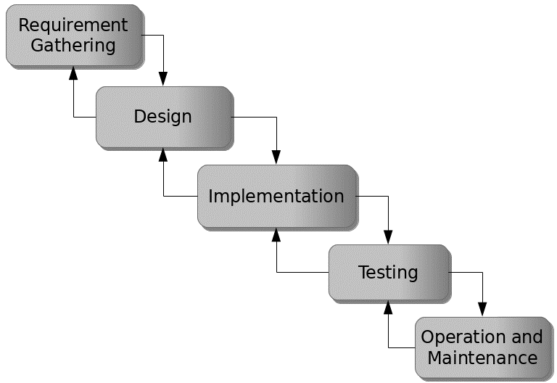

Figure 3.1: Waterfall model

## 3.5 Method of Data Collection

This study will adopt two methods of data collection which are the primary and secondary method.

## 3.6 System Design

Systems design is the process of defining the architecture, modules, interfaces, and data for a system to satisfy specified requirements. Systems design could be seen as the application of systems theory to product development.

## 3.6.1 Algorithm Diagram

**Use Case Diagram**

A use case diagram at its simplest is a representation of a user’s interaction with the system and depicting the specifications of a use case.

Login

Add Student

System settings

View/Edit/Delete

Admin

Add User

Print Report

Log out

Search

Figure 3.2: Use case diagram

**3.6.2 System Architecture**



Database MySQL

Apache Server

Database Management Model

Figure 3.2: System Architecture

**3.6.3 Database Tables/Queries Structures**

## Table 3.1: Employees Table

|  |  |  |  |  |
| --- | --- | --- | --- | --- |
| **Field** | **Datatype (length)** | **Null** | **Key** | **Extra** |
| id | int(10) | NO | PRIMARY | auto_increment |
| Employee_id | int(10) | YES |  |  |
| Firstname | varchar(50) | YES |  |  |
| Middlename | varchar(50) | YES |  |  |
| Lastname | varchar(50) |  |  |  |
| Email | varchar(50) |  |  |  |
| Date of Birth | varchar(50) |  |  |  |
| Gender | varchar(50) |  |  |  |
| Phone Number | varchar(50) |  |  |  |
| Address | varchar(50) |  |  |  |
| LGA | varchar(50) |  |  |  |
| State | varchar(50) |  |  |  |
| Country | varchar(50) |  |  |  |
| Marital Status | varchar(50) |  |  |  |
| Photograph | varchar(50) |  |  |  |
| Leave date | varchar(50) |  |  |  |
| Position | Varchar(50) |  |  |  |
| Date | timestamp |  |  |  |

**Table 3.3: Admin Login Table**

|  |  |  |  |
| --- | --- | --- | --- |
| **Field** | **Type** | **Key** | **Extra** |
| id | int(10) | PRI | auto_increment |
| First name | varchar(50) |  |  |
| lastname | varchar(50) |  |  |
| Username | varchar(50) |  |  |
| Password | varchar(50) |  |  |
| Photograph | varchar(50) |  |  |
| Date | timestamp |  |  |

**3.6.4 Entity Relationship Diagram**

This shows the relationship of the various tables in the database with each other

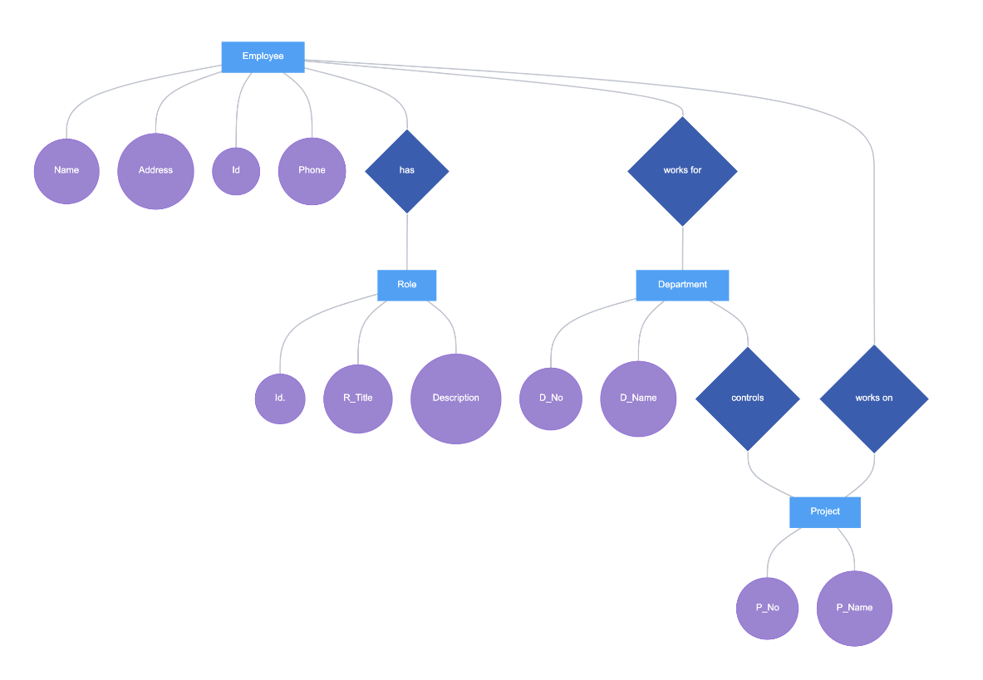

Figure 3.4: Entity Relationship Diagram

**3.6.5 Input and Output Design**

**LOGIN**

Enter Username

Enter Password

**Login**

Figure 3.5: Login interface

First name

Gender:

Address:

Course Studied

**ADD STUDENT RECORD**

Birth Place

Parent Name

Phone Number

Grade

Curriculum

Last Name:

State

Total years

Registration No

Other name:

Date of Birth:

LGA of Origin:

From – To

**SUBMIT**

**CANCEL**

Figure 3.6: Add Student Form

| **Registration No** | **Name** | **Grade** | **Full Details** |
| --- | --- | --- | --- |
| ST/CS/ND/21/101 | DIWA FAVOUR | ACCOUNTANT | VIEW |
| ST/CS/ND/21/005 | IBRAHIM MUSA | ADMIN HR | VIEW |

Figure 3.7: Report Interface

## 3.7 System Requirements Specification

**3.7.1 Hardware Requirements**

The software designed needed the following hardware for an effective operation of the newly designed system.

1. A system running on intel, P(R) duo core with higher processor
2. The-Random Access Memory (RAM) should be at least 512mb.
3. Enhanced keyboard.
4. At least 20-GB hard disk.
5. V.G.A or a colored monitor.

**3.7.2 Software Requirements**

The software requirements include:

1. A window 7 or higher version of operating system.
2. XAMP or WAMP for Database
3. PHP

## 3.7.3 Personnel Requirements

Any computer literate who has a technical knowhow of internet surfing can use the system because it is user friendly.

# CHAPTER FOUR

# RESULTS AND DISCUSSION

## 4.1 Introduction

The new system is designed using PHP and MySQL programming language for easy records inserting and updating. This system will help in managing and easily retrieving of information from the system for management purposes. The new system Student with National Diploma for computer science department.

## 4.2 Results

## 4.2.1 Welcome Interface

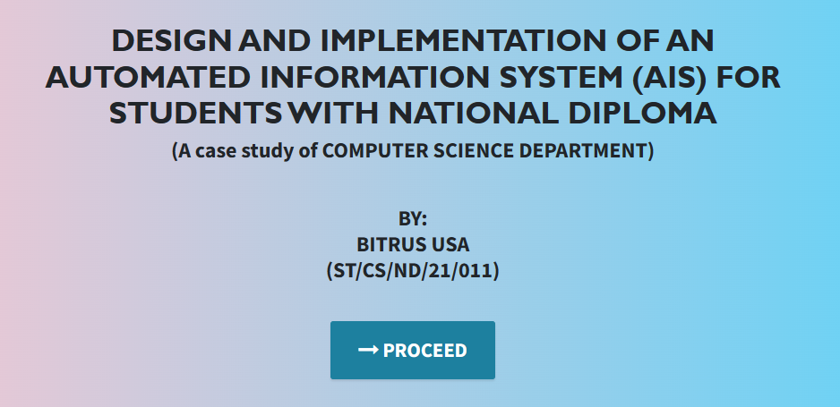

Figure 4.2.1: Welcome Interface

The above figure 4.2.1 shows the welcome page of the Student with National Diploma in computer science, the welcome page is the first page that displays on opening the program.

## 4.2.2 Login Interface

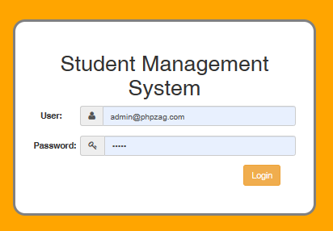

Figure 4.2.2: Login page interface

Figure 4.2.2 above shows the system login page interface. The login interface allows the users and Administrator to enter his username and password to get access to the system.

## 4.2.3 Add Students Interface

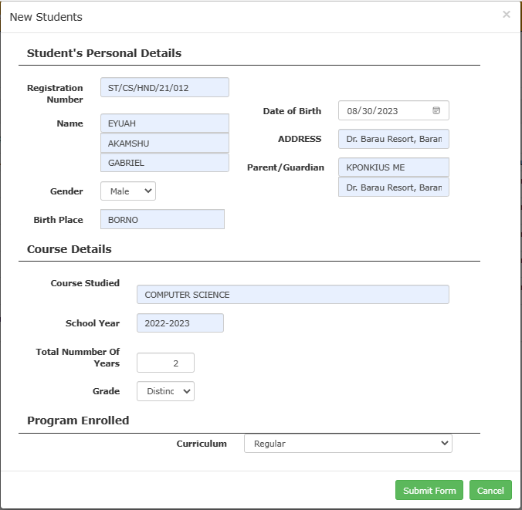

Figure 4.2.3: Add Students Interface

Figure 4.2.3 above shows where students with National diploma details will be added to the system for records purposes.

## 4.2.4 Add Users interface

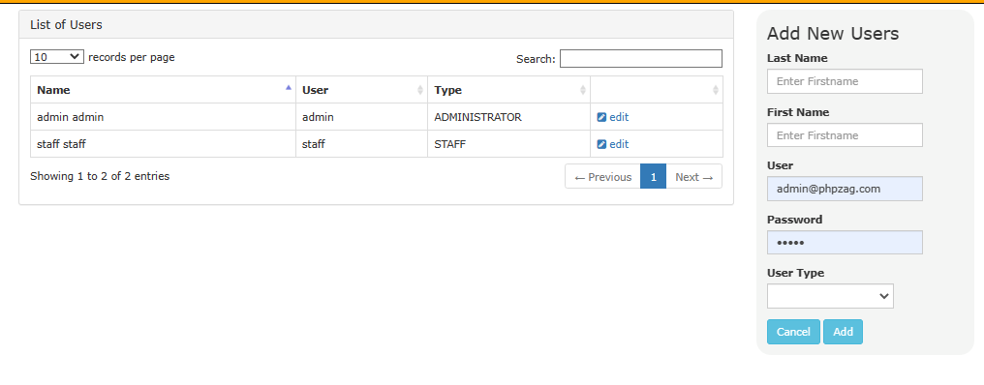

Figure 4.2.4: Add Users Interface

Figure 4.2.4 is used to add users into the system who can also add students records into the system.

## 4.2.5 Students List Interface

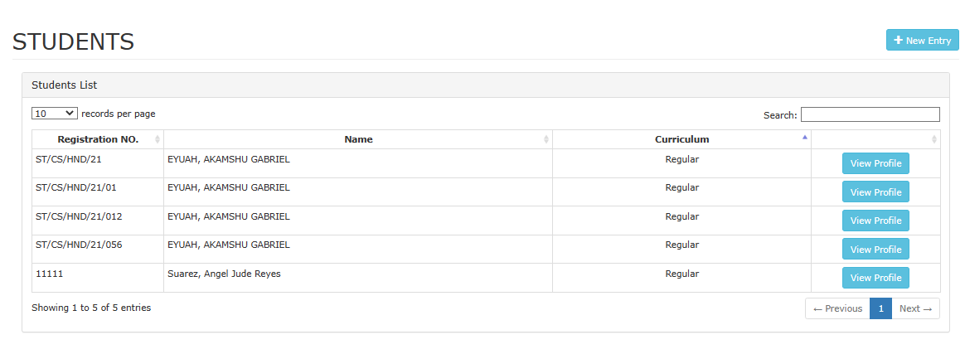

Figure 4.2.5: Student List Interface

Figure 4.2.5 above displays all the students that have been added into the system.

## 4.2.6 Add Academic Session

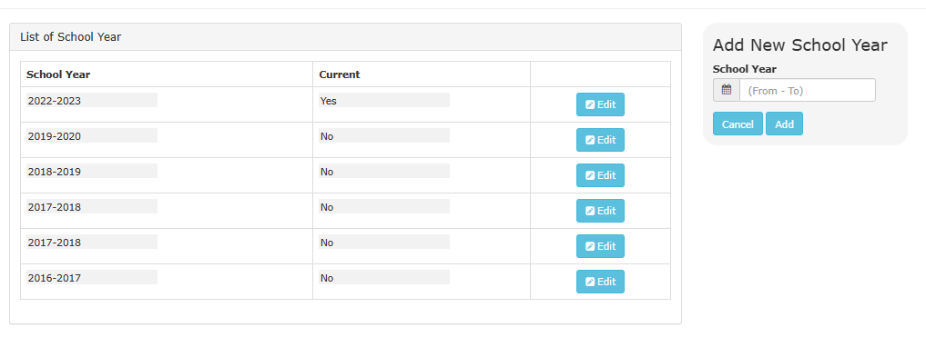

Figure 4.2.6: Add Academic Session

Figure 4.2.6 above is used to set or add academic session into the system that will be used for registering students with National Diploma.

## 4.3 Discussion

Figure 4.1 Welcome Interface: The Welcome Interface serves as the entry point for users accessing the Automated Information System (AIS). It typically includes a welcoming message and provides an overview of the system's capabilities. Users are usually presented with options to navigate further into the system, such as logging in, accessing student-related features, or accessing academic session-related functions.

Figure 4.2 Login Interface: The Login Interface is where users provide their login credentials to access the AIS securely. It typically includes fields for entering usernames and passwords. Additionally, there may be options for password recovery or account creation if applicable.

Figure 4.3 Add Students Interface: The Add Students Interface allows authorized users, such as administrators or faculty members, to input information about new students. This interface typically includes fields for entering student details, including names, contact information, enrollment data, and program information. Users can use this interface to register new students within the Computer Science Department.

Figure 4.4 Add Users Interface: The Add Users Interface enables administrators to add new users to the system, such as faculty members, staff, or other authorized personnel. It typically includes fields for entering user details, including names, roles, contact information, and access permissions. This interface ensures that the AIS maintains accurate user records.

Figure 4.5 Students List Interface: The Students List Interface displays a comprehensive list of students enrolled in the Computer Science Department. It typically includes student names, identification numbers, contact details, program enrollment information, and academic progress data. This interface is valuable for faculty and administrators for tracking and managing student information.

Figure 4.6 Add Academic Session Interface: The Add Academic Session Interface is used to manage the academic calendar within the Computer Science Department. Authorized users can input information related to academic sessions, including start and end dates, holidays, and important academic events. This interface ensures that the system accurately reflects the department's academic schedule.

These interfaces collectively form the user interface components of the Automated Information System (AIS) for Students with National Diploma within the Computer Science Department. They are designed to streamline administrative tasks, enhance user experience, and maintain accurate records and data related to student enrollment and academic sessions.

## 4.4 User manual

The following are the necessary steps to take in order to use the system efficiently and effectively.

1. Load the url of the system <https://localhost/studentND/> the welcome page will be displayed.
2. Click on the **Proceed** button to proceed to the main system.
3. If you created an account, provide your login details by entering your username and password.
4. Depending on the login details provided you will be automatically directed to the dashboard.
5. The various task that you can perform on the portal will be displayed on the sidebar of the dashboard.

# CHAPTER FIVE

# SUMMARY, CONCLUSION AND RECOMMENDATIONS

## 5.1 Summary

In summary, the "Design and Implementation of an Automated Information System (AIS) for Students with National Diploma" represents a significant advancement in the realm of academic administration and student management within the Computer Science Department. This innovative system streamlines and automates various administrative processes, including student registration, record-keeping, and academic session management, enhancing efficiency and data accuracy.

The AIS provides an intuitive and user-friendly platform that benefits both students and departmental staff, facilitating smoother operations and improved communication. By successfully implementing this system, the Computer Science Department has set a precedent for how technology can enhance the management of students and academic sessions in educational institutions.

## 5.2 Conclusion

The design and implementation of the Automated Information System (AIS) for Students with National Diploma have yielded tangible benefits for the Computer Science Department. This project demonstrates the transformative potential of technology in streamlining administrative tasks, enhancing data accuracy, and improving overall operational efficiency within academic institutions.

The AIS has not only simplified the student management process but also provided a robust platform for departmental staff to access and maintain student records efficiently. Moreover, it has contributed to improved communication and transparency within the department.

## 5.3 Recommendations

Based on the successful implementation of the AIS, several recommendations can be made for its continued enhancement and broader adoption:

1. User Training: Provide comprehensive training to all users to maximize the system's benefits and ensure efficient utilization.
2. Data Integration: Explore opportunities for integrating the AIS with other institutional systems, such as academic records and financial management, for a more comprehensive student information ecosystem.
3. Enhanced Reporting: Develop advanced reporting and analytics features to provide departmental staff with valuable insights into student performance, trends, and enrollment data.
4. Security Measures: Continuously monitor and enhance data security measures to safeguard sensitive student information and maintain trust.

## 5.4 Contribution to Knowledge

This project contributes to knowledge in several key areas:

Educational Technology: It exemplifies how technology can significantly improve administrative processes within academic departments, leading to enhanced operational efficiency.

Student Management: The AIS demonstrates the potential of automated systems to simplify student registration, record-keeping, and academic session management, reducing manual workloads.

## 5.5 Area for Further Work

Future work in this area could include:

Mobile Accessibility: Developing a mobile application version of the AIS to cater to users who prefer mobile access.

AI and Analytics: Exploring the integration of artificial intelligence and advanced analytics to predict enrollment trends, course demand, and student success factors.

Cross-Departmental Integration: Extending the system's capabilities for use in other academic departments to promote a standardized approach to student management.

User Feedback: Continuously seeking user feedback and conducting usability studies to refine and improve the AIS based on user needs and preferences.

# REFERENCES

Adams, K. (2022). The Role of Automation in Educational Financial Management. *Journal of Information Technology in Education,* 15(3), 120-135.

Aguinis, K., & Kraiger, J. (2022). The Impact of Payment Systems on Error Reduction in Educational Institutions. *International Journal of Educational Finance,* 20(1), 56-70.

Allen, D. & James, M. (2021). Retaining Talent: The Relationship between Rewards, Engagement, and Turnover. *Journal of Management,* 46(8), 1300-1328.

Allen, D. G., Bryant, P. C., & Vardaman, J. M. (2021). Retaining Talent: The Relationship between Rewards, Engagement, and Turnover. *Journal of Management,* 46(8), 1300-1328.

Anderson, L., & Schalk, S. (2018). Ensuring Data Security in Payment Systems for Educational Institutions. *International Journal of Cybersecurity*, 18(1), 45-60.

Armstrong, M. (2019). *Armstrong's Handbook of Human Resource Management Practice*. Kogan Page Publishers.

Bendl, Y. (2021). Application of Predictive Modeling in Education: A Review. *Journal of Computers in Education,* 8(1), 19-37.

Cable, S. M., & Judge, A. (2016). Success Factors and Barriers of Adopting the Automated System of Student Affairs in Saudi Universities. *International Journal of Higher Education,* 8(3), 1-9.

Denisi, U. & Kluger, W. (2020). Mobile Property Management Systems: A Study of Design and Implementation. *Information Systems Frontiers*, 1-14.

Elmasri, R., & Navathe, S. B. (2019). *Fundamentals of Database Systems.* Pearson, New York.

Ghazal, O., Ionita, H. & Gorges, O. (2020). An Artificial Intelligence Platform for Property Management: *A Conceptual Model. Computers in Industry*, 125, 103-379.

Goblar, N. (2022). Decision Support System in Higher Education: A Case Study of an Adaptive Learning Management System. *Journal of Computers in Education,* 8(2), 215-239.

Illmakunnas, H. (2023). Adoption of E-payment Systems in Higher Education: A Comparative Study*. International Journal of Educational Technology*, 14(3), 57-72.

Jagero, R., & Kangethe, A. (2020). The Importance of Financial Transparency in Educational Institutions. *Journal of Education Finance and Policy,* 25(2), 89-104.

Jurban, L., Turner, R., & Gonzalez, E. (2023). Improving Financial Management in Universities with Payment Systems. *Journal of Higher Education Management,* 16(2), 78-92.

Kalesh, S. & Tuwei, J. (2022). Web-based Rental Property Management System for Efficient and Effective Property Management. *Journal of Engineering Technology*, 18(1), 221-229.

Kapoor, A., & Singh, P. (2020). Digital Transformation in Compensation and Benefits Management. *International Journal of Recent Technology and Engineering*, 9(2), 6742-6746.

Lazear, S., & Rosen, M. (2023). Student Perspectives on Payment Systems in Higher Education. *International Journal of Educational Technology*, 15(1), 34-48.

Liu, K., Letchkov, N., Koychev, I., & Ivanov, B. (2020). Cloud-Based Property Management Systems. *In Proceedings of the International Conference on Advances in Business, Management and Law*, 7(1), 169-177.

Mahmud, N. (2020). Evaluation of Records Management Systems in Public Universities in Kenya. *International Journal of Information Systems and Project Management,* 8(3), 43-62.

Martins, A., Proença, T., & Gonçalves, R. (2020). Employee Compensation, Incentives, and Innovation. *Research in Human Resource Management (RHRM),* 12(1), 45-54.

Mathe, U., Lee, L., Ming, I., & Hashim, L. (2021). The Role of Management Information Systems in Data Analytics: A Strategic Perspective on Global Business Environments. *Information Systems Frontiers,* 22(4), 909-924.

Motahari-Nezhad, H. R., Stephenson, B., Shahbazian, M., & Foster, H. (2021). Database Management Systems. *In Handbook on Securing Cyber-Physical Critical Infrastructure* (pp. 195-217). Springer.

Olivera, M. & Martins, L. (2021). The Adoption of Property Management Systems in the Real Estate Sector. *Journal of Business and Management*, 23(2), 71-92.

Poon, J. M. (2019). The Impact of Non-Financial Rewards on Employee Engagement and Retention. *Employee Relations*, 41(2), 333-348.

Rahman, L., Huang, O., Tim, R. & Gehrke, J. (2020). *Database Management Systems*. McGraw-Hill.

Ramakrishnan, M. & Gehrke, M. (2020). An Integrated Framework for E-Records Management System (ERMS) Development: A Study on Bangladesh Government Sector. *International Journal of Electronic Government Research*, 16(3), 19-38.

Reddy, B. S., & Kumar, G. P. (2021). Personalized Compensation and Benefits: A New Paradigm. *International Journal of Applied Engineering Research*, 16(1), 69-73.

Rizvi, S., Khan, M. A., Bhatti, R. A., & Ziauddin, Z. (2021). A Comparative Study of Database Management Systems. *Journal of Information Systems and Technology Management*, 18, 202-1134.

Shore, F. (2019). A Model for Developing a Student Management System (SMS) in Saudi Universities. *Journal of Educational Computing Research,* 58(3), 523-552.

Singhal, J. (2021). Digital Transformation in Higher Education: Advancements and Challenges. *International Journal of Educational Technology,* 12(4), 65-79.

Tziner, J. & Vardi, K. (2018). Cloud-Based Property Management System with Mobile Integration for Small and Medium-Sized Landlords. *Journal of Systems and Information Technology*, 23(3), 486-503.

Vroom Q. (2017). A Framework for Smart Rental Property Management. *IEEE Access*, 8, 134127-134139.

Wasana, A. (2020). Design and Development of Mobile Applications for Property Management. *International Journal of Information Systems and Project Management,* 9(2), 5-19.

Wayne, K. (2022). Digitalizing Student Fee Management: Challenges and Opportunities. *Journal of Educational Administration,* 46(1), 89-105.

Welch, M., & Jackson, S. E. (2017). Rethinking Diversity in Research on Organizations: Toward a Structural Perspective. *Research in Organizational Behavior*, 27, 3-30.

Wu, L., & Zhu, C. (2021). Security Considerations in Designing University Payment Systems. *Journal of Information Security,* 35(2), 213-228.

# APPENDIX A

## Welcome Interface



## Login Interface



## Add Students Interface



## Add Users interface



## Students List Interface



## Add Academic Session



# APPENDIX B

**PROGRAM CODE**

<!DOCTYPE html>

<html lang="en">

  <head>

    <meta charset="utf-8">

    <meta name="viewport" content="width=device-width, initial-scale=1, shrink-to-fit=no">

    <meta name="description" content="">

    <meta name="author" content="">

    <title>NATIONAL DIPLOMA</title>

    <!-- Bootstrap Core CSS -->

    <link href="vendor/bootstrap/css/bootstrap.min.css" rel="stylesheet">

    <!-- Custom Fonts -->

    <link href="vendor/font-awesome/css/font-awesome.min.css" rel="stylesheet" type="text/css">

    <link href="https://fonts.googleapis.com/css?family=Source+Sans+Pro:300,400,700,300italic,400italic,700italic" rel="stylesheet" type="text/css">

    <link href="vendor/simple-line-icons/css/simple-line-icons.css" rel="stylesheet">

    <!-- Custom CSS -->

    <link href="css/stylish-portfolio.min.css" rel="stylesheet">

  </head>

  <body id="page-top" style=" background: linear-gradient(90deg, pink, rgb(67, 207, 250));">

    <!-- Header -->

    <header class="masthead d-flex">

      <div class="container text-center">

        <h1 class="mb-2" style="font-size: 45px; font-weight: bolder; font-family: 'Gill Sans', 'Gill Sans MT', Calibri, 'Trebuchet MS', sans-serif; text-transform: uppercase;"><span style=" margin-top:15px;"> DESIGN AND IMPLEMENTATION OF AN Automated Information System (AIS) for students with National Diploma</span> <br>  </h1>

        <h2 class="mb-3" style="">(A case study of COMPUTER SCIENCE DEPARTMENT)</h2><br><br>

        <h2>BY: <br> BITRUS USA <br> (ST/CS/ND/21/011)</h2> <br>

        </h3>

        <br>

        <strong><a class="btn btn-primary btn-xl js-scroll-trigger" href="grading/login.php" style="font-size: 30px;"><span class="fa fa-long-arrow-right"></span> PROCEED</a></strong>

        <br> <br> <br>

        <!-- <h4 class="alert alert-success"><a href="onlinefood-order/admin/index.php">Admin Login Here!</a></h4> -->

              </div>

      <div class="overlay"></div>

    </header>

    <!-- Scroll to Top Button-->

    <a class="scroll-to-top rounded js-scroll-trigger" href="#page-top">

      <i class="fa fa-angle-up"></i>

    </a>

    <!-- Bootstrap core JavaScript -->

    <script src="vendor/jquery/jquery.min.js"></script>

    <script src="vendor/bootstrap/js/bootstrap.bundle.min.js"></script>

    <!-- Plugin JavaScript -->

    <script src="vendor/jquery-easing/jquery.easing.min.js"></script>

</html>

<h1>Welcome to <?php echo $_settings->info('name') ?></h1>

<hr class="bg-light">

<?php if($_settings->userdata('type') != 3): ?>

<div class="row">

          <div class="col-12 col-sm-6 col-md-3">

            <div class="info-box">

              <span class="info-box-icon bg-light elevation-1"><i class="fas fa-file-alt"></i></span>

              <div class="info-box-content">

                <span class="info-box-text">Pending Applications</span>

                <span class="info-box-number text-right">

                  <?php

                    $pending = $conn->query("SELECT * FROM `leave_applications` where date_format(date_start,'%Y') = '".date('Y')."' and date_format(date_end,'%Y') = '".date('Y')."' and status = 0 ")->num_rows;

                    echo number_format($pend            </div>

            <!-- /.info-box -->

          </div>

          <!-- /.col -->

          <div class="col-12 col-sm-6 col-md-3">

            <div class="info-box mb-3">

              <span class="info-box-icon bg-info elevation-1"><i class="fas fa-building"></i></span>

              <div class="info-box-content">

                <span class="info-box-text"> Departments</span>

                <span class="info-box-number text-right">

                  <?php

                    $department = $conn->query("SELECT id FROM `department_list` ")->num_rows;

                    echo number_format($department);

                  ?>

                </span>

              </div>

              <!-- /.info-box-content -->

            </div>

            <!-- /.info-box -->

          </div>

          <!-- /.col -->

          <!-- fix for small devices only -->

          <div class="clearfix hidden-md-up"></div>

          <div class="col-12 col-sm-6 col-md-3">

            <div class="info-box mb-3">

              <span class="info-box-icon bg-lightblue elevation-1"><i class="fas fa-th-list"></i></span>

              <div class="info-box-content">

                <span class="info-box-text"> Designations</span>

                <span class="info-box-number text-right">

                <?php

                    $designation = $conn->query("SELECT id FROM `designation_list`")->num_rows;

                    echo number_format($designation);

                  ?>

                </span>

              </div>

              <!-- /.info-box-content -->

            </div>

            <!-- /.info-box -->

          </div>

          <div class="col-12 col-sm-6 col-md-3">

            <div class="info-box mb-3">

              <span class="info-box-icon bg-purple elevation-1"><i class="fas fa-list"></i></span>

              <div class="info-box-content">

                <span class="info-box-text">Promotion Types</span>

                <span class="info-box-number text-right">

                <?php

                    $leave_types = $conn->query("SELECT id FROM `leave_types` where status = 1 ")->num_rows;

                    echo number_format($leave_types);

                  ?>

                </span>

              </div>

              <!-- /.info-box-content -->

            </div>

            <!-- /.info-box -->

          </div>

        </div>

<?php else: ?>

  <div class="row">

    <div class="col-12 col-sm-6 col-md-3">

      <div class="info-box">

        <span class="info-box-icon bg-light elevation-1"><i class="fas fa-file-alt"></i></span>

        <div class="info-box-content">

          <span class="info-box-text">Pending Applications</span>

          <span class="info-box-number text-right">

            <?php

              $pending = $conn->query("SELECT * FROM `leave_applications` where date_format(date_start,'%Y') = '".date('Y')."' and date_format(date_end,'%Y') = '".date('Y')."' and status = 0 and user_id = '{$_settings->userdata('id')}' ")->num_rows;

              echo number_format($pending);

            ?>

            <?php ?>

          </span>

        </div>

        <!-- /.info-box-content -->

      </div>

      <!-- /.info-box -->

    </div>

    <div class="col-12 col-sm-6 col-md-3">

      <div class="info-box">

        <span class="info-box-icon bg-lightblue elevation-1"><i class="fas fa-th-list"></i></span>

        <div class="info-box-content">

          <span class="info-box-text">Promotion Requests</span>

          <span class="info-box-number text-right">

            <?php

              $upcoming = $conn->query("SELECT * FROM `leave_applications` where date(date_start) > '".date('Y-m-d')."' and status = 1 and user_id = '{$_settings->userdata('id')}' ")->num_rows;

              echo number_format($upcoming);

            ?>

            <?php ?>

          </span>

        </div>

        <!-- /.info-box-content -->

      </div>

      <!-- /.info-box -->

    </div>

  </div>

<?php endif; ?>